**Module -2 : EC2 and EBS Assignment -2**

1. Launched a Linux EC2 instance named “my_ec2”

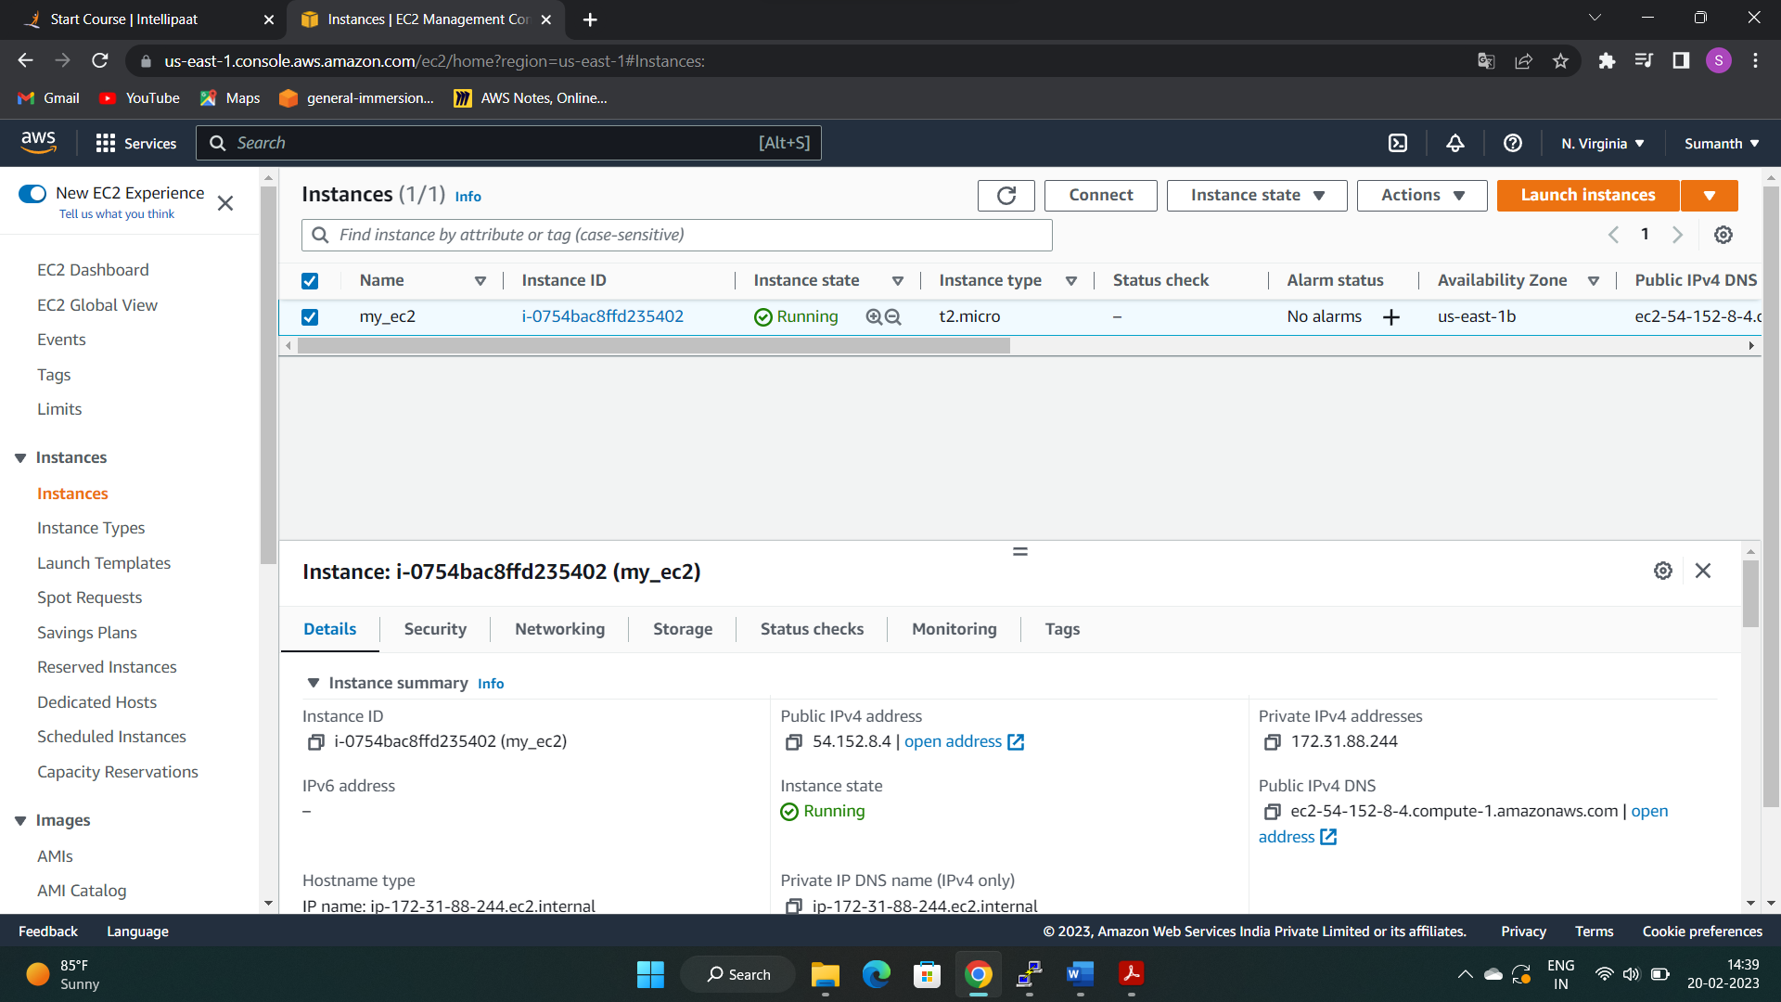

1. Created an EBS volume with 20GB of storage

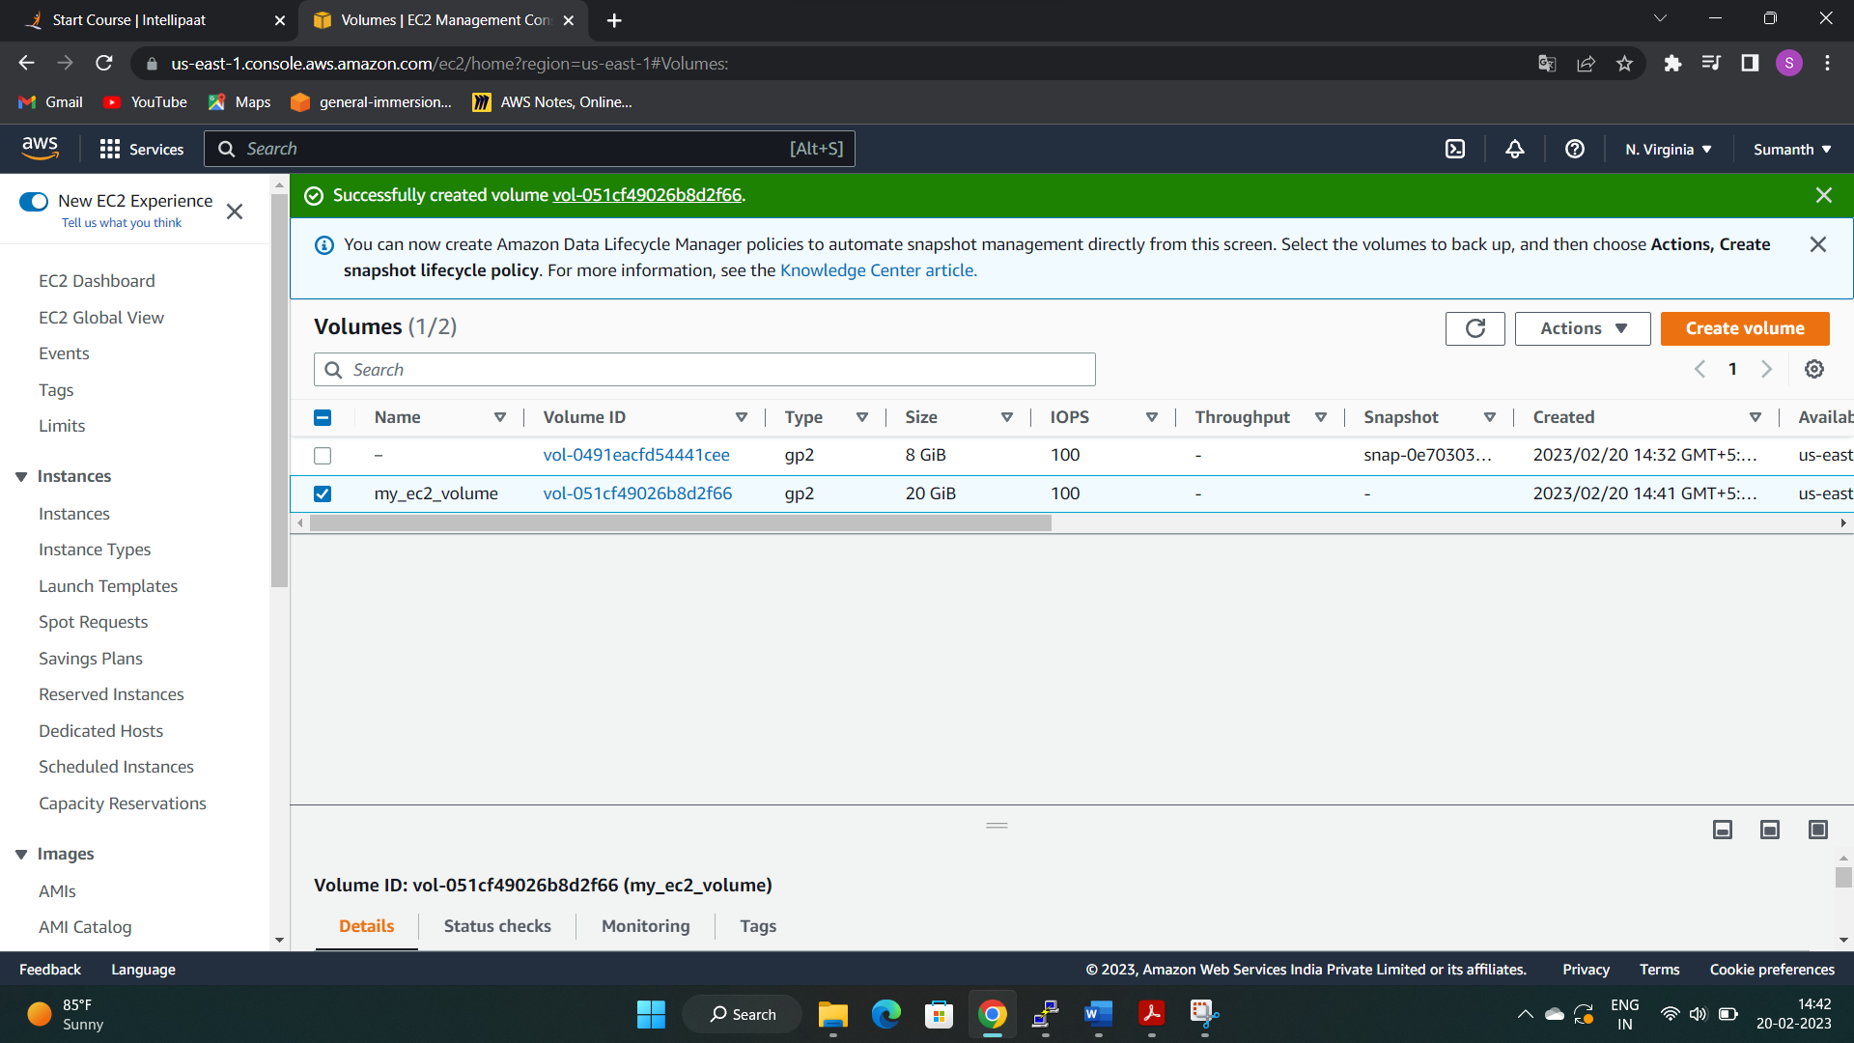

1. Attached an EBS volume to my EC2 instance

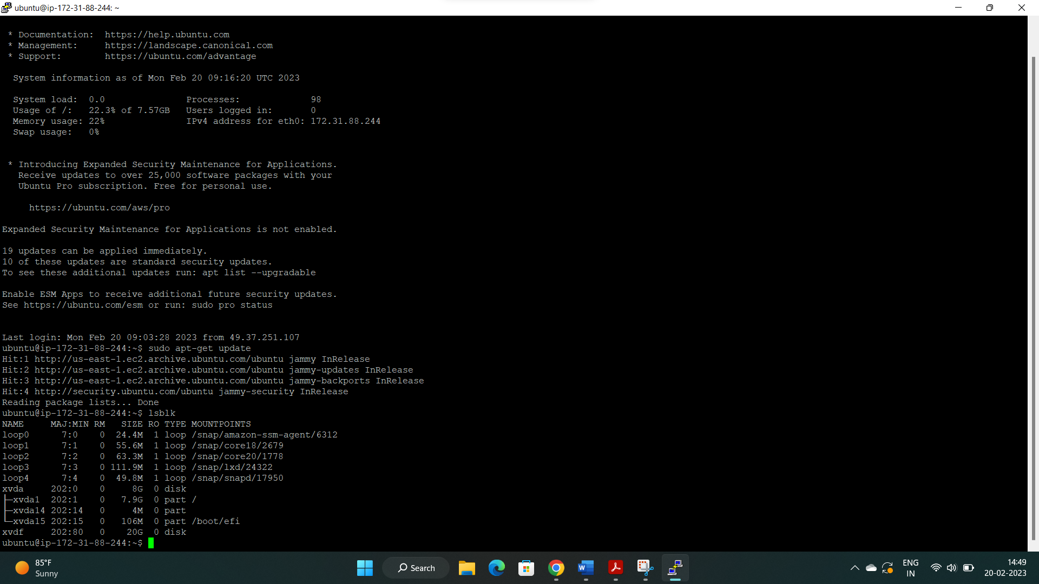

1. Re-sized the attached EBS volume to 40GB

